Lab #2: Painting Class

*Carson Kramer*

*February 9th, 2023*

ALGORITHM

Step 1 – Initialize local variables, global variables, and instance of room

Ex. Length, Width, Height, paintPerGallon, gallonsNeeded, room1

Step 2 – Do-while loop (repeating until -1 is entered for any value)

Step 3 – In do-while loop, prompt user

Prompt user with separate function, passing variables by reference. Use error checking with cin here

Step 4 – Call set functions of room instance (prompt user function error checked previously)

Step 4.5 – Create calcVolume() and calcPaintedArea() functions to be used in Step 5

calcVolume() multiplies length, width, and height together

calcPaintedArea() uses surface area equation, without ceiling and floor values

Step 5 – showData() called to display newly set Length, Width, Height, alongside calcVolume() and calcPaintedArea()

Step 6 – Calculate and print the gallons needed with the global variable paintPerGallon

gallonsNeeded = calcPaintedArea() / paintPerGallon

Step 7 – Repeat Step 3 through 6 until -1 entered

SCREEN-SHOTS OF RUNNING PROGRAM

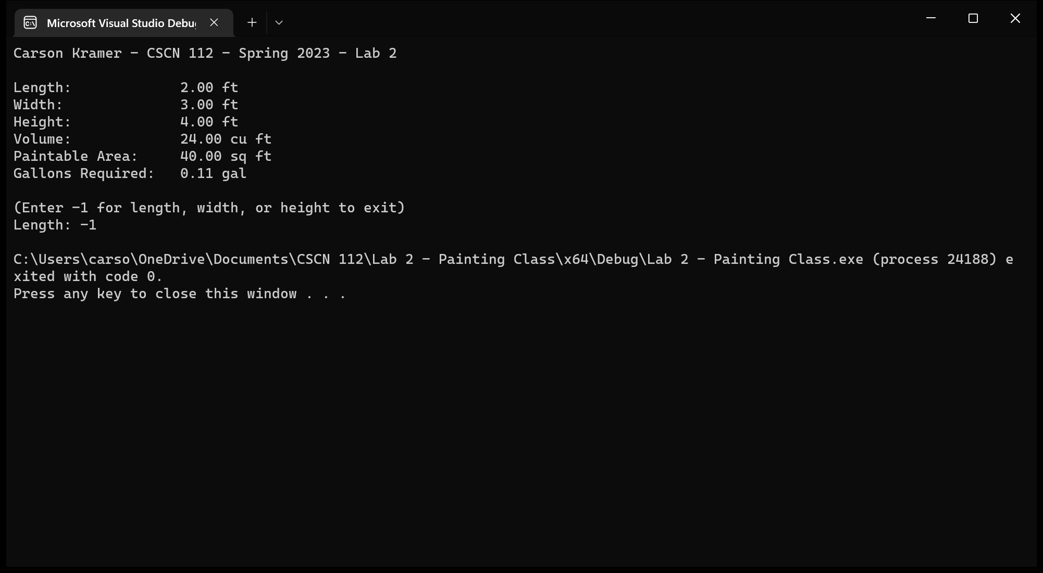

INTEGRITY STATEMENTS

* I have not shared the source code in my program with anyone other than the pre-approved human sources.
  + *Please include a note here if you have used one or more of the pre-approved human sources or received special permission from me.*
* I have not used source code obtained from another student, or any other unauthorized source, either modified or unmodified.
* If any source code or documentation used in my program was obtained from another source, such as the course textbook or course notes, that has been clearly noted with a proper citation in the comments of my program.
  + It would also be helpful to include a note here of which sources you used
* I have not knowingly designed this program in such a way as to defeat or interfere with the normal operation of any machine it is graded on or to produce apparently correct results when in fact it does not.

Note: These statements serve as your personal promise that the above is true. If I find that you have not been true to ALL of the four statements above, you will get a zero for the assignment and receive an academic violation report (which goes on your academic record). Both are minor compared to the loss of your integrity.